–1974  Sitting: Bobcia  Front Row: Eleanor, Mary, Frank, Pete, Al, Tony, Fred  Second Row: Donald, Harold, Grace, Dolly, Evelyn, Gloria, Olga  Back Row: Dave, Josephine, Julian, Andrea  1998  Front Row: Josephine, Eleanor, Andrea, Al, Mary  Back Row: Bill, Tony, Pete, Fred, Frank  Happy Trails to one and all  Until we meet again (5 years?)  D | DOMBROWSKI “20” YEAR FAMILY REUNION  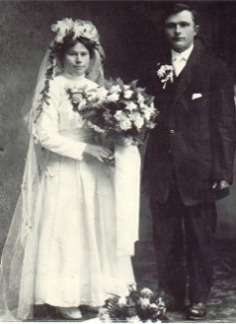  THE FOUNDATION  Stanislave (Stella) Milecki &  Stanislwaw Dombrowski  01.12.1914  The Marvelous 10  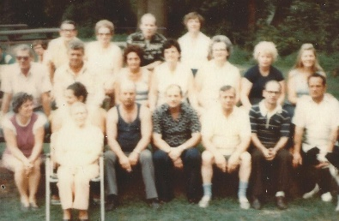 1974  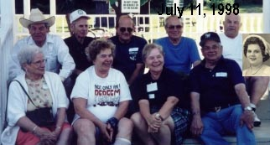 1998

Mountain View Park, 104 Mount View Park Lane Tannersville PA  Sunday, September 2, 2018  NO COST…. BYO food/refreshments & charcoal. Grills available  NO… confetti or glitter, alcohol beverages or glass bottles…  NO… dogs or pets (except service dogs)…  NO SMOKING… (tobacco or e-cigarettes)  9:00 a.m. ARRIVE, SET UP, & WELCOME  9:30 Throughout the day: Face Painting, Connect 4, Checkers, Tick-Tack-Toe, Corn Hole  10:00. Speed Dating “Introduction”. Every 10 minutes move to the next table (6 moves in 1 hour)  - 2nd and 3rd Generation ALWAYS STAYS at the table and introduces self:  - I am the son/daughter of ___________________  - I live ___________________________________  - I am a _______________________ for ____ years  - I have ___ children, ___ grandchildren, and  ____ great grandchildren  - My hobby is _____________________________  - 4th, 5th, and 6th Generation ONLY MOVES to the next table to introduce yourself:  - I am the son/daughter of ___________________  - I live ___________________________________  - I am a _______________________ for ___ years  - I have ___ children, ___ grandchildren  - My hobby is ____________________________    11:15 Review Family Tree:  See where your leaf is on the tree    12:00 Lunch and Socialize | 1:00  Group Family Photo / Photo Booth  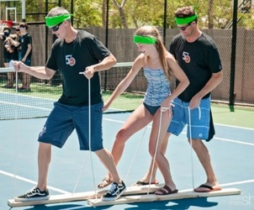  2:00 Getting to Know You Bingo:  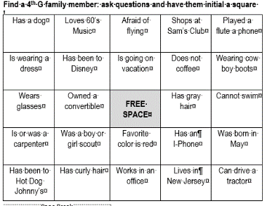  - Bingo cards will be passed out to everyone. Each person who has a bingo card will ask a family member to initial a few boxes that applies to them. Once the card is full, return for a “Reunion Memento.”  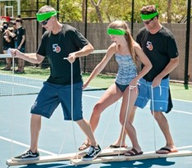  3:00 Select a team of 3 for:  Walk the Board-Walk Relay Race  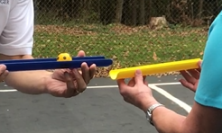  4:00 Select a team of 10 for:  PVC Gutter Ball Race  5:00 Dinner and Socialize  6:00 PACK UP & FAREWELLS  7:30 EXIT PARK……PARK CLOSES

